Chapter 5, Solution 31.

For the circuit in Fig. 5.69, find i_{x}.

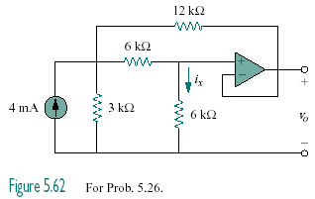

Figure 5.69
For Prob. 5.31.

Solution

After converting the current source to a voltage source, the circuit is as shown below:

3 kΩ

6 kΩ

12 V

+
−

1
+
−

6 kΩ

12 kΩ

v_{o}

v_{o}

v₁

2

At node 1,
48 = 7v₁ - 3v_{o} (1)

At node 2,
v₁ = 2v_{o} (2)

From (1) and (2),
727.2 µA

